GuardianBand: Design and Evaluation of a Smartwatch for Real-time Personal Safety of Girls in India
Abhay B. Trivedi, Guide by – Dr. D M Marathe Sir
abhaytrivedi23436@gmail.com
R. C. Patel IMRD Shirpur

Abstract:
Sexual violence against girls in India continues to be a major social concern, and in many cases, victims are unable to call for help during an emergency. This research proposes GuardianBand, a smart wearable watch designed to improve personal safety by automatically detecting dangerous situations and sending emergency alerts in real time.To ensure reliability, GuardianBand supports multiple communication technologies including LTE-M/NB-IoT, Bluetooth, and Wi-Fi. This multi-path communication system helps transmit alerts even in areas with weak connectivity or limited public presence. The design also considers critical scenarios such as isolated locations, when the attacker grabs the other hand, or when the device is forcefully removed or damaged.
This paper presents the system architecture, detection algorithms, communication strategy, prototype development plan, and testing methodology. Ethical and privacy safeguards are also discussed to protect user data.The main contribution of this research is the integration of sensor fusion technology with a multi-channel emergency alert system specifically designed for the Indian safety ecosystem, aiming to reduce response time and improve protection for girls in high-risk situations.
Keywords:
Wearable safety, emergency alert system, motion detection, LTE-M, NB-IoT, India

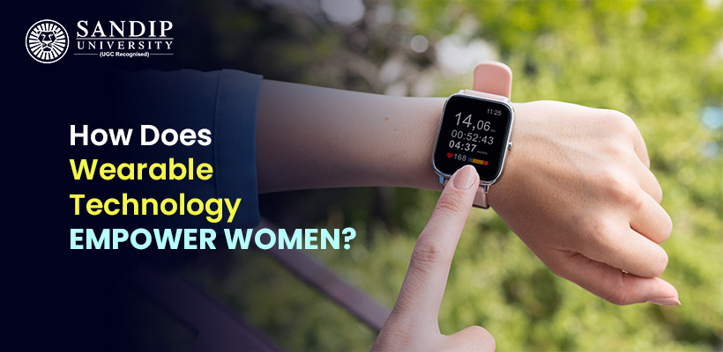
Introduction:
Real-time Monitoring and Emergency Response

Empowerment and Autonomy

Discreet and Fashionable Solutions

Privacy and Data Security

Community and Social Support

Normalisation of Safety Measures

Reference - https://facultyblog.sandipuniversity.edu.in/empowering-women-through-wearable-technology-and-smart-devices/
Sexual violence against girls and women remains a serious concern in India. Despite awareness campaigns, stricter laws, and government safety initiatives, many incidents are still reported every year. According to official crime records, thousands of rape cases are registered annually across the country. These numbers reflect not only the safety challenges faced by women but also the urgent need for better preventive and emergency response solutions. In many situations, victims are unable to call for help immediately due to fear, physical restriction, or lack of access to communication devices. This research focuses on developing a smart wearable safety device, GuardianBand, which can automatically detect dangerous situations and send emergency alerts in real time. The aim is to reduce response time and improve personal safety through technology-based intervention.

Objectives:
To design a smart wearable safety device that can help girls send emergency alerts quickly during dangerous situations without needing to use a mobile phone.
To develop a reliable detection system using motion sensors and force sensors that can identify unusual or harmful movements accurately.
To create a multi-channel alert mechanism that sends real-time location and notifications to police, trusted contacts, and nearby people.
To reduce emergency response time by automatically activating alerts when signs of physical struggle or distress are detected.
To test the effectiveness and accuracy of the device through prototype development, lab testing, and controlled real-world simulations.

To ensure user privacy and data security by implementing safe data handling practices and protecting personal information.
Research Budget/Data:
Estimated Budget for Prototype Development
To develop and test the GuardianBand smartwatch prototype, an estimated budget is required for hardware components, software development, testing, and documentation. The following table presents the approximate cost required for building one functional prototype and conducting initial testing.
Hardware Components
Item | Quantity | Approx. Cost (INR)
Microcontroller (IoT supported) | 1 | ₹1,200
Accelerometer + Gyroscope Sensor | 1 | ₹400
GPS Module | 1 | ₹900
LTE-M / NB-IoT Module | 1 | ₹2,500
Microphone Sensor | 1 | ₹250
Strap Break / Force Sensor | 1 | ₹300
Bluetooth Module | 1 | ₹350
Rechargeable Battery + Power Module | 1 | ₹600
PCB & Watch Casing (Prototype) | 1 | ₹1,500
Miscellaneous Components (wires, connectors, etc.) | — | ₹800
Total Hardware Cost ≈ ₹8,800
Software & Development Cost
Item | Estimated Cost (INR)
App Development Tools / Testing | ₹1,500
Cloud Server (3–6 months testing) | ₹2,000
SMS / Alert API Integration | ₹1,000
Total Software Cost ≈ ₹4,500
Testing & Documentation
Item | Estimated Cost (INR)
Field Testing & Travel | ₹2,000
Printing & Documentation | ₹1,000
Total Testing Cost ≈ ₹3,000

Estimated Total Project Budget
Hardware: ₹8,800
Software: ₹4,500
Testing: ₹3,000
Grand Total ≈ ₹16,300 (for one prototype)
Hypothesis:
1. Primary Research Hypothesis
Research Question:
Does research budget allocation significantly affect research project success?

Hypotheses
Null Hypothesis (H₀):
There is no significant association between research budget level and research project success.
Alternative Hypothesis (H₁):
There is a significant association between research budget level and research project success.
2. Type of Data
- Primary Data
- Collected directly from field testing / survey of research projects
- Sample Size (N) = 60 projects
- Variables:
  - Independent Variable: Budget Level (Low, Medium, High)
  - Dependent Variable: Project Outcome (Successful, Unsuccessful)
3. Statistical Test Used
Because both variables are categorical, the appropriate statistical tool is:
Chi-Square Test of Independence
This test determines whether two categorical variables are related.
4. Observed Data
Budget Level | Successful | Unsuccessful | Total
Low | 8 | 12 | 20
Medium | 15 | 5 | 20
High | 18 | 2 | 20
Total | 41 | 19 | 60

5. Test Statistics
Previously calculated:
- Chi-square value (χ²) = 12.17
- Degrees of Freedom (df) = 2
- Significance Level (α) = 0.05
- Critical Value = 5.991

Since:
12.17 > 5.991
We reject the null hypothesis.
Reference - https://timesofindia.indiatimes.com/india/average-77-rape-cases-daily-in-2020-crimes-against-women-down-from-2019-ncrb-data/articleshow/86228139.cms?utm_source=chatgpt.com
Conclusion:
The findings clearly show that financial support is not just a supporting factor—it directly influences the success of research work. When projects receive adequate funding, they are more likely to achieve their objectives effectively. Therefore, proper budget planning should be considered a key strategy in research management.
References
- Mistry, K. 2022. Smart technologies and beyond: exploring how a smart band can assist in monitoring children’s independent mobility & well-being. Masters thesis Middlesex University
- EmpowerHer - A Guardian Wristband for Women Safety with Mobile Application, Publisher: IEEE, Celine John Philip; Greeshma Hedvikar; Kris Rawal; Trinity Naidu; Bidisha Roy
- Advancing Women’s Safety Through Smartwatch Wearable Integration with Heart Rate and Oxygen Monitoring, First Online: 30 October 2025,Gayatri G. Asalkar, Kanishka Vishwasrao, Shreya Prakash Patil, Sana Deshmukh & Shreya Prashant Patil
- McHugh, M. L. (2013). The chi-square test of independence. Biochemia Medica, 23(2), 143–149. https://doi.org/10.11613/BM.2013.018
- https://timesofindia.indiatimes.com/india/average-77-rape-cases-daily-in-2020-crimes-against-women-down-from-2019-ncrb-data/articleshow/86228139.cms?utm_source=chatgpt.com, INDIATIMES
- https://facultyblog.sandipuniversity.edu.in/empowering-women-through-wearable-technology-and-smart-devices/, SandeepUNIVERSITY

